Dr. OP Singh’s

Bio Courses

Worksheets for cracking NEET ……..

Chapter 2 Sexual Reproduction in Flowering Plants

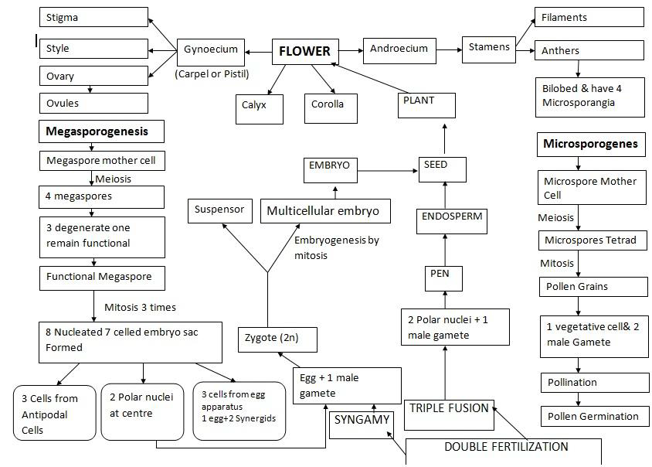

**Fill the appropriate words in the blanks**

